SECTION 1: Hands-On Demonstration

Part 1. Analyze a Windows Server 2012 Machine

1. describe the security issue for the MS15-011 missing update:

Updates are not checked.

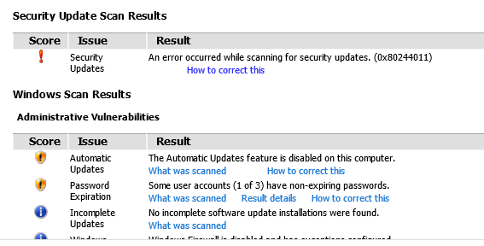

1. number of missing security updates for the Windows Security Updates issue (screen capture):

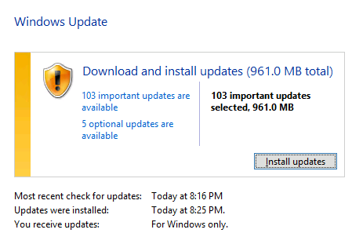

3. for every other issue identified in the scan results with a Result details link, describe a plan for correcting the issue, if any, on this machine; if you determine that the issue requires no corrective action, explain your decision:

SECTION 2: Applied Learning

Part 1. Analyze a Windows Server 2016 Machine

1. the Password Policy in the GPO report (screen capture):

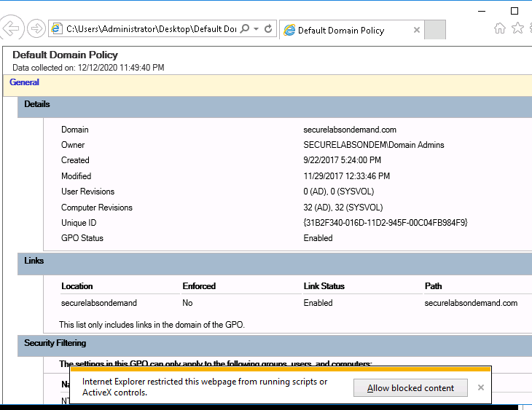

1. the current PasswordAge settings in the Policy Viewer (screen capture):

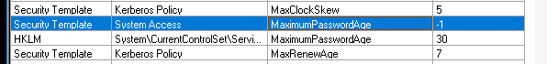

SECTION 3: Observation Summary

We first run a batch file to get the environment ready for the test. Then we RDP into the remote machine and run the MBSA. We specify the IP of the computer that we want to scan, which is the current computer. We saw that the updates are not automatic so we changed the windows to check to updates automatically but let us choose when to install them.

We run the bat file to get the environment ready for the lab. Then we RDP into the remote machine and we launch the server manager to open group policy editor.